BUAN 6390 Analytics Practicum

Group Project Report

**Above the Clouds: Performance Analysis of Airline Operations**

Group 3 - eMarket Mavericks

Team Members:

Bhargav Sukhavasi ​

Keerthi Kolli ​

Krishna Vamshi Nethi ​

Min Shi​

Rahil Shah

Table of Contents

I. Project Introduction 3

Problem Statement 3

Objective 3

II. Overview of Airline Industry 3

Dominant Players: The Big Four and Beyond 3

The Big Four: 3

Beyond the Big Four: 4

Market Dynamics: Consolidation vs. Competition 4

Factors Shaping the Industry 4

The Future of US Airlines 4

III. Assessment of Financial Performance of Top 4 Airlines 5

Net Income Analysis 5

Net Income Over Years by Airline 5

Total Net Income by Airline and Region 6

Operating Profit or Loss Analysis 6

Operating Profit or Loss Over Years by Airline 6

Total Operating Profit or Loss by Airline and Region 7

IV. Top 4 Airlines Revenue Analysis 8

General Trends 8

Two Major Dips in Revenue 9

Breaking Down Revenue in Key Components by Revenue Category 9

Passenger Transportation Revenue 9

Transporting Goods Revenue (Cargo) 9

Total Operating Revenue 10

Analyzing Top 4 Airline’s Passenger Transportation Revenue by Region 11

V. Top 4 Airlines Operating Expense Analysis 12

Overall Operating Expense Analysis 12

Individual Airlines Analysis 12

Comparative Analysis 13

Operating Expense Composition 14

VI. Insights & Recommendation 14

VII. Summary 15

# I. Project Introduction

## Problem Statement

* Challenges in the airline industry: Volatile fuel prices, fluctuating demand, and evolving consumer preferences.
* Intense competition: Airlines must strategically manage operational costs and revenue streams to sustain profitability.
* Making informed decisions is crucial: Assess financial health and performance to understand industry dynamics.

## Objective

* Evaluate the overall financial and revenue health of the top 4 airlines during 2002-2023.
* Investigate operating expenses to identify areas of shortness and opportunities for improvement for top 4 airlines.
* Combining big events, alliances and partnerships to generate comprehensive context analysis of top 4.

# II. Overview of Airline Industry

The airline industry is all about transporting people and cargo by air. Airlines offer scheduled flights between destinations, or chartered flights for specific purposes. It's a major player in the travel industry, and critical for global commerce.

## Dominant Players: The Big Four and Beyond

### The Big Four:

* As highlighted in Figure 1, American Airlines, Delta Air Lines, United Airlines, and Southwest Airlines are the undisputed leaders in the US market.
* Table 1 illustrates the historical progression of mergers and acquisitions that led to the establishment of the four largest airlines in the U.S. They boast extensive route networks, large fleets, and brand recognition.
* Each has a distinct niche: American focuses on a global network, Delta prioritizes customer service, United emphasizes efficiency, and Southwest is known for its low-cost model.

Figure 1 Market Share of Top 8 Airlines and Others during 2002-2023

Table 1 Top 4 US Airlines Introduction

### Beyond the Big Four:

The pie chart in Figure 1 shows the significant presence of other players (30% market share).

This includes:

* ***Regional Airlines:*** These smaller carriers operate shorter routes and feed into the networks of major airlines, providing crucial connectivity to smaller cities.
* ***Budget Airlines:*** Carriers like Spirit and Frontier offer lower fares by using smaller aircraft, limiting amenities, and employing cost-saving measures.
* ***Legacy Carriers:*** These are airlines that have undergone mergers or restructurings, like the now-defunct Continental Airlines and US Airways (reflected in the older pie chart).

## Market Dynamics: Consolidation vs. Competition

* ***Consolidation***: The industry has seen a trend towards consolidation, with mergers creating larger airlines with more bargaining power with airports and suppliers.
* This can lead to increased efficiency and route optimization, but also raises concerns about reduced competition and potentially higher fares.
* ***Competition***: Despite consolidation, the presence of regional and budget airlines fosters competition. This keeps prices in check and compels major airlines to offer competitive fares and services.

## Factors Shaping the Industry

* ***Fuel Costs:*** A major expense for airlines, fuel price fluctuations can significantly impact profitability. Airlines use hedging strategies to mitigate some risk but remain vulnerable to external factors like oil price wars.
* ***Economic Conditions:*** Passenger demand is highly sensitive to economic conditions. During recessions, travel tends to decline, impacting airline revenue.
* ***Regulations***: Strict government regulations regarding safety, security, and environmental impact can affect airlines' operations and profitability.
* ***Technology***: Advancements in areas like fuel-efficient aircraft, automated flight operations, and online booking platforms are transforming the industry.

## The Future of US Airlines

* ***Focus on Fuel Efficiency***: Airlines will prioritize strategies like utilizing newer, more fuel-efficient aircraft and optimizing flight paths to reduce fuel consumption.
* ***Passenger Experience***: Airlines will likely invest in enhancing in-flight amenities, entertainment options, and personalized services to attract and retain passengers, especially in the competitive long-haul market.
* ***Technology Integration*:** Digital solutions will play a larger role in streamlining operations, improving maintenance efficiency, and providing a seamless travel experience for passengers (e.g., mobile boarding passes, self-service kiosks).
* ***Sustainability:*** Environmental concerns are pushing airlines to adopt cleaner technologies like biofuels and explore alternative energy sources for powering aircraft.
* Understanding the US airline industry requires considering the interplay between dominant players, diverse competitors, external factors like fuel costs and regulations, and the ever-evolving technological landscape. As the industry navigates these challenges and opportunities, its future lies in embracing efficiency, innovation, and a focus on the evolving needs of passengers.

# III. Assessment of Financial Performance of Top 4 Airlines

Airlines' financial health is commonly assessed through net income and operating profit or loss metrics.

## Net Income Analysis

Net income represents the total profit or loss after all expenses, including taxes and interest, are deducted.

### Net Income Over Years by Airline

Over the past 20 years, the top four airlines have experienced periods of negative or low net income, notably during the 2008 financial crisis and the COVID-19 pandemic, as shown in Figure 2.

Figure 2 Net Income of Top 4 Airlines by Year during 2002-2023

#### American Airlines' Financial Challenges:

Specifically, American Airlines displayed net income around zero or below from 2002 to 2014. This can be attributed not only to general economic downturns but also to high debt levels and the airline's bankruptcy and restructuring in 2011. Historically, American Airlines faced higher labor costs compared to its peers, and it was among the few that had not renegotiated labor agreements post-9/11, leading to a burdensome cost structure. Operational inefficiencies, including flight delays and poor customer service, further eroded its profitability. However, post-merger with US Airways in 2013, its financial situation showed signs of improvement.

#### Delta Air Lines' Strategic Shift:

Delta Air Lines' net income trends reveal dips during the 2008 financial crisis and the pandemic, with a notable increase in 2013. Post-merger with Northwest Airlines in 2010, despite reducing jet fuel consumption, Delta's fuel costs escalated, significantly impacting expenses. In response, Delta acquired an oil refinery in 2012, significantly reducing its fuel costs and helping stabilize future financial outcomes.

#### United Airlines' Volatility:

United Airlines has shown the most fluctuation in net income. For instance, it reported a significant loss in 2005 but recovered in 2006. The airline's financial struggles included high labor costs and operational inefficiencies, exacerbated by the Chapter 11 bankruptcy from December 2002 to February 2006. Post-bankruptcy, United implemented significant cost reductions including labor renegotiations and fleet optimization, which contributed to a financial turnaround by 2007.

#### Southwest Airlines' Stability:

Southwest Airlines has demonstrated the most stable net income over the past two decades, as illustrated in Figure 3. From 2002 to 2023, Southwest was the only airline to consistently report positive net income from its domestic operations. This indicates that the Southwest adopted a relatively successful business model which we will discuss in detail later.

In summary, while each airline has faced unique challenges, strategic decisions and market focus have played crucial roles in determining their financial trajectories over the past two decades.

### Total Net Income by Airline and Region

Unlike its peers, Southwest primarily focuses on domestic routes and its net income is the highest among the top 4 airlines. Key factors contributing to its steady financial performance include an aggressive fuel hedging strategy, the operation of a single aircraft type (Boeing 737), a point-to-point routing model, and low-cost operations. These strategies have enabled Southwest to maintain lower operational costs and higher profitability in domestic markets compared to its competitors.

American Airlines, over the past twenty years, has experienced significant financial challenges, with a substantial net loss, particularly in domestic operations, amounting to nearly -$8,000,000. This is followed by operations across the Atlantic, showing losses of -$3,000,000, and Pacific operations, with losses around -$2,500,000. However, American Airlines earns the most from local flight operations compared to the other top three airlines.

Delta Airline has incurred a total negative net income of approximately -$2,000,000 in local flight operations. Its domestic flights also faced losses, albeit smaller. Notably, Delta's operations across the Pacific Ocean have generated the highest positive net income among the top four airlines, and it has also achieved positive net income from flights across the Atlantic Ocean. Overall, Delta has performed well in transcontinental operations.

Lastly, United Airlines has recorded positive net income only from its flights across the Atlantic, while facing losses in domestic, local, and Pacific operations. However, it is worth mentioning that United earns the most from its across-Atlantic Ocean flights among the top four airlines.

Figure 3 US Top 4 Airlines’ Total Net Income by Region from 2002 to 2023

## Operating Profit or Loss Analysis

Operating profit or loss is the profit or loss from core business operations, excluding investments, taxes, or interest expenses.

### Operating Profit or Loss Over Years by Airline

As shown in Figure 4, the trends for US top 4 airlines are similar. Among the top 4 airlines, Delta Air Lines emerged as the most profitable airline between 2011 and 2019 due to a combination of strategic initiatives and operational efficiencies:

* Fuel Hedging: Delta’s acquisition of an oil refinery in 2012 helped manage volatile fuel costs more effectively than competitors.
* Fleet Modernization: Upgrading to newer, more fuel-efficient aircraft reduced maintenance and operational costs.
* Operational Excellence: High performance in on-time arrivals, customer satisfaction, and baggage handling enhanced brand reputation and reduced costs.
* Customer Service and Brand Loyalty: Investments in in-flight experiences and loyalty programs enhanced customer retention.
* Strategic Partnerships: Joint ventures with international carriers expanded Delta’s global network and market reach.
* Cost Discipline: Despite growth investments, Delta maintained strict control over operating expenses.
* Economic Recovery Leverage: Capitalizing on the post-recession recovery in travel demand, Delta expanded services in key markets.

These strategies collectively contributed to Delta’s profitability, distinguishing it in the airline industry throughout the period.

Figure 4 US Top 4 Airlines Operating Profit/Loss during 2002-2023

### Total Operating Profit or Loss by Airline and Region

Figure 5 US Top 4 Airlines’ Total Operating Profit/Loss by Region from 2002 to 2023

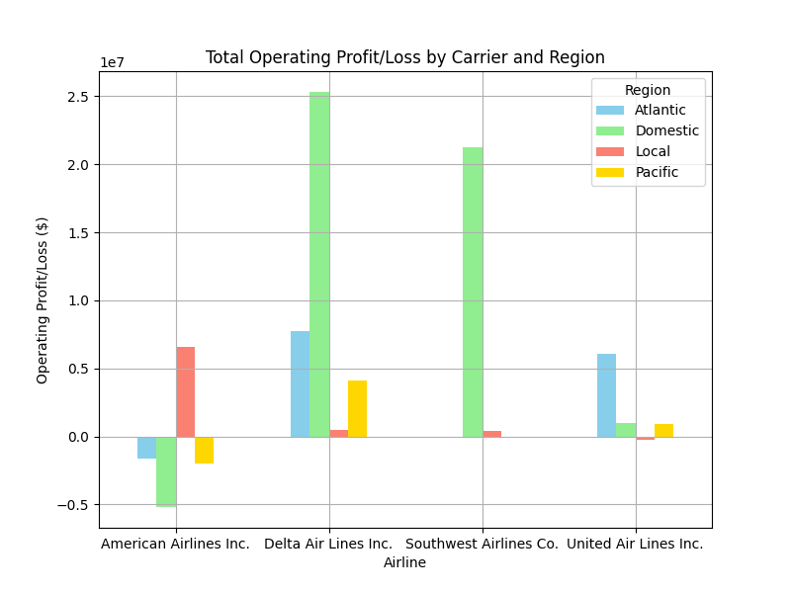

Based on Figure 5, it is evident that Delta Air Lines has been the most profitable airline over the past twenty years, achieving higher earnings relative to costs in all four regions: domestic, local, across the Pacific, and across the Atlantic. Among these regions, Delta generated the highest profits from domestic operations, followed by the Atlantic, Pacific, and local flights.

Southwest is the second most profitable airline, operating solely in domestic and local markets. Remarkably, 95% of its profits come from domestic flights, while local flights contribute just about 5%.

United Airlines ranks third in profitability, with the most substantial earnings from Atlantic routes. It also profits from domestic and Pacific operations but incurs some losses in local flights.

American Airlines, meanwhile, is the least profitable among the top four, with overall negative profits. Specifically, it faces substantial losses in domestic operations and also records losses in Pacific and Atlantic routes. Its only profit comes from local flights.

# IV. Top 4 Airlines Revenue Analysis

The US airline industry is a major economic driver, facilitating passenger and cargo transportation across the country and beyond. Understanding the revenue landscape of this industry is crucial for various stakeholders, including investors, travelers, and policymakers. This analysis delves into the overall revenue structure and performance of the four leading US airlines: American Airlines, Delta Air Lines, Southwest Airlines, and United Airlines. By examining their revenue streams, growth trends, and key factors influencing income, we aim to gain a comprehensive picture of the financial health and competitive dynamics within the US airline sector. This analysis will provide insights into the airlines' strategies for generating revenue, their susceptibility to external factors, and their potential for future growth. Overall airline revenue is typically calculated as total passenger revenue (fares, fees) plus cargo revenue plus other ancillary revenue streams (e.g., in-flight meals, lounge access).

Figure 6 US Top 4 Airlines’ Total Revenue from 2002 to 2023

## General Trends

* Total revenue appears to be increasing over the years for all four airlines.
* Delta Airlines seems to have the highest total revenue among the four airlines throughout the years shown in the chart, followed by American Airlines, United Airlines and Southwest Airlines.
* The revenue seems to fluctuate from year to year for all four airlines.

## Two Major Dips in Revenue

The provided chart reveals two significant dips in total revenue for all four airlines (American, Delta, Southwest, and United) across the years. These dips coincide with major economic events that heavily impacted the airline industry:

1. Global Financial Crisis of 2008: This major economic downturn significantly impacted consumer spending. People traveled less due to job insecurity, decreased disposable income, and a general sense of economic uncertainty. This translates to fewer airline tickets being sold, leading to a drop in revenue for all airlines.
2. COVID-19 Pandemic (2020): The global pandemic caused a near standstill in air travel. Strict travel restrictions, border closures, and public health concerns discouraged people from traveling. Airlines were forced to significantly reduce flight schedules, resulting in a substantial decline in revenue.

## Breaking Down Revenue in Key Components by Revenue Category

### Passenger Transportation Revenue

This is the bread and butter of airline revenue, typically accounting for the largest portion of their income. It directly reflects passenger demand for air travel and the airline's ability to sell seats at profitable fares.

Consistent passenger revenue growth is crucial for airlines to cover operational costs, invest in new aircraft, and generate profits. Fluctuations in passenger demand can significantly impact airlines' financial stability.

Figure 7 US Top 4 Airlines’ Passenger Transportation Revenue during 2002-2023

Based on Figure 7, we could detect:

* Total Passenger revenue appears to be increasing over the years for all four airlines, except for a major dip in 2020.
* Delta Airlines seems to have the highest total passenger revenue among the four airlines throughout the years shown in the chart, followed by American Airlines, United Airlines and Southwest Airlines.
* The revenue seems to fluctuate from year to year for all four airlines, with significant dips in 2008 and 2020.

### Transporting Goods Revenue (Cargo)

The following chart showing cargo transportation revenue for the top four US airlines (American, Delta, Southwest, and United) offers valuable insights into their performance in this specific revenue stream.

Figure 8 US Top 4 Airlines’ Transportation Goods Revenue during 2002-2023

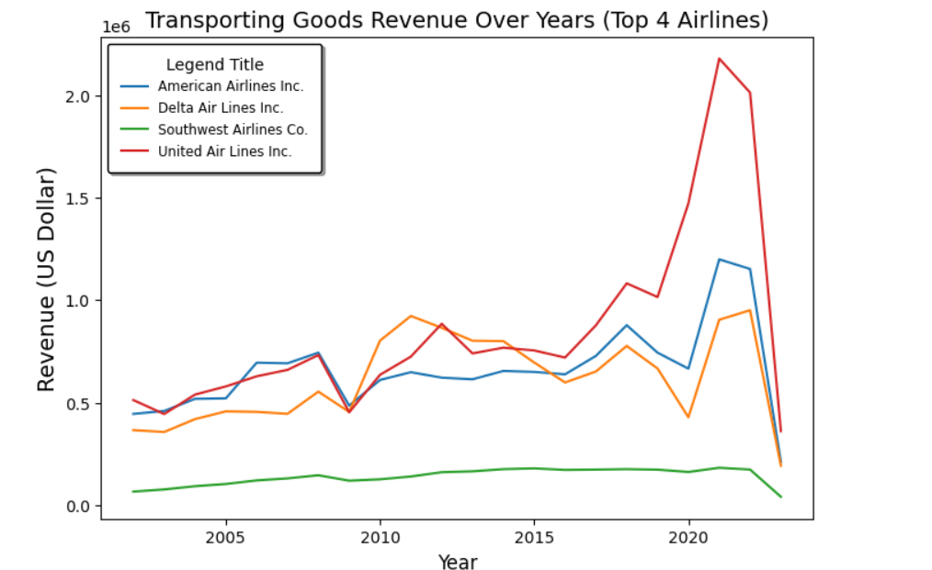

#### United Airlines has highest transportation goods revenue:

* United has a long history of emphasizing cargo operations. They were one of the first US airlines to acquire dedicated freighter aircraft in the 1970s, giving them a head start in building a strong cargo network and infrastructure.
* United boasts a vast network of domestic and international destinations, including major cargo hubs like Chicago O'Hare and Hong Kong. This extensive network allows them to cater to a wider range of cargo transportation needs.
* United has historically focused on transporting high-value and time-sensitive cargo, such as pharmaceuticals, electronics, and fresh produce. This focus on profitable cargo segments likely contributes to their strong revenue performance.
* United has established strategic alliances with other cargo airlines, allowing them to offer seamless cargo services across a broader global network. This expands their reach and potential customer base.

#### Southwest Airlines has lowest transportation goods revenue:

* Southwest's core business strategy revolves around offering low-cost passenger fares. This focus might have resulted in less investment in dedicated cargo operations compared to airlines like United, American, and Delta.
* Southwest's fleet primarily consists of Boeing 737 aircraft, designed for maximum passenger capacity. This might leave less space available for cargo compared to airlines with dedicated freighter aircraft or passenger planes with larger cargo holds.

### Total Operating Revenue

Figure 9 US Top 4 Airlines’ Operating Revenue during 2002-2023

The operating revenue seems to be increasing over time for all four airlines, with the exception of a major dip in 2020, as shown in Figure 9. This suggests an overall positive trend in revenue generation, but also vulnerability to external factors.

Delta Airlines appears to have the highest operating revenue throughout the years shown in the chart, followed by American Airlines, United Airlines and Southwest Airlines. There seems to be a slight gap between the top 3 airlines (Delta, American, United) and Southwest Airlines.

The factors drive Delta Airlines' leading in operating revenue include: 1) The successful merger with Northwest Airlines in 2008 created a larger, more competitive airline with a wider route network and increased operational efficiency. 2) Network Optimization: Delta have strategically added new routes to high-demand destinations. 3) Revenue Management Improvements: Delta have implemented advanced revenue management practices.

## Analyzing Top 4 Airline’s Passenger Transportation Revenue by Region

Although Southwest has relatively lower total and subcategory revenues compared to the other top three airlines, it is important to note that Southwest focuses exclusively on the U.S. domestic market. Additionally, they operate fewer average roundtrip flights and have fewer total routes per day, serving significantly fewer airports, as detailed in Table 2.

Table 2 US Top 4 Airline Comparison in Roundtrip Flights, Seats/Flights, Airports Serves, etc.

|  |  |  |  |  |  |
| --- | --- | --- | --- | --- | --- |
| **Airline** | **Average Roundtrip Flights Per Day (February 2024)** | **World Ranking** | **Seats/Flights** | **Airports Served (February)** | **Total Routes (February)** |
| American Airlines | 5625 | 1 | 129 | 335 | 1096 |
| Delta Airlines | 4266 | 2 | 139 | 279 | 845 |
| United Airlines | 4066 | 3 | 133 | 322 | 878 |
| Southwest Airlines | 3715 | 4 | 159 | 121 | 820 |

Figure 10 US Top 4 Airlines’ Total Passenger Transportation Revenue

by region during 2002-2023

Since passenger transportation revenue is the most important component of total revenue, we divide the top 4 airlines’ passenger transportation revenue by regions and the results is shown in Figure 10. It is evident that Southwest operates solely in domestic and local regions, whereas the other top three airlines also serve across-Atlantic and across-Pacific regions. Despite focusing exclusively on the domestic market, Southwest's total passenger transportation revenue ranks third, closely trailing American Airlines and Delta Airlines.

# V. Top 4 Airlines Operating Expense Analysis

The operating analysis report provides an in-depth examination of the operational performance of four major airlines: American Airlines Inc., Delta Air Lines Inc., Southwest Airlines Co., and United Air Lines Inc. The report analyzes key metrics such as total operating expenses, operating revenue, net income, and operating efficiency to gain insights into the financial health and profitability of each airline. By examining trends and patterns in operating data, the report aims to provide valuable insights for stakeholders and decision-makers in the aviation industry.

## Overall Operating Expense Analysis

The overall analysis of operating expenses across all airlines reveals an intriguing pattern, as shown in Figure 11. From 2017 to 2019, there is a general upward trend in operating expenses, indicating a growth in costs associated with airline operations. However, 2020 presents a stark deviation from this trend, with a sharp increase in operating expenses for most airlines. This anomaly can be attributed to the unprecedented impact of the COVID-19 pandemic, which led to widespread disruptions in the airline industry, resulting in increased costs related to safety measures, fleet management, and operational adjustments.

Figure 11 Rolling Average of Operation Expenses during 2002-2023

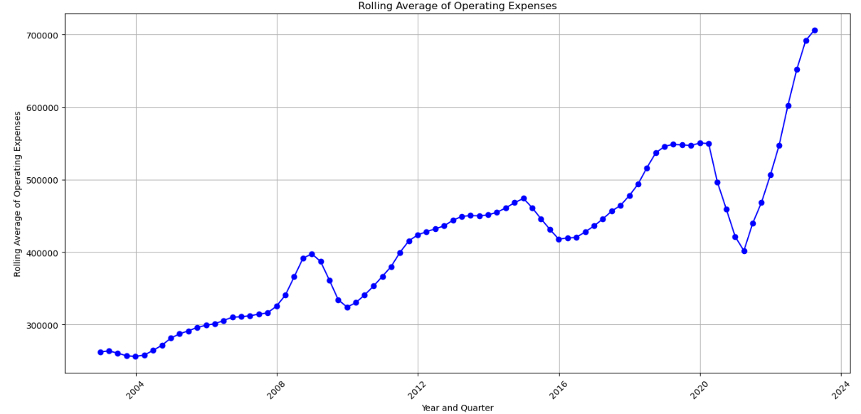

## Individual Airlines Analysis

Figure 12 Total Operating Expenses of American, Delta, Southwest and United Airlines

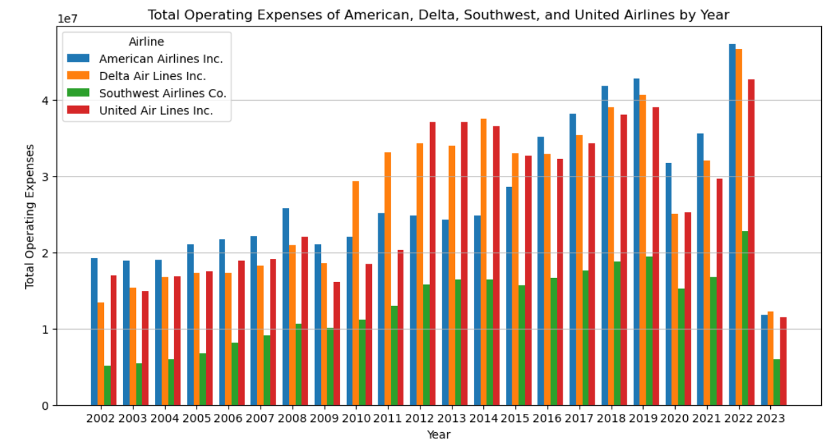

When examining the operating expenses of individual airlines, namely American Airlines Inc., Delta Air Lines Inc., Southwest Airlines Co., and United Air Lines Inc., distinct patterns emerge (as shown in Figure 12). American Airlines Inc. and Delta Air Lines Inc. exhibit similar trends, with steady increases in operating expenses from 2017 to 2019, followed by significant spikes in 2020. Southwest Airlines Co., however, maintains relatively stable operating expenses until 2020, when a slight increase is observed. United Air Lines Inc. experiences fluctuations in operating expenses, with a notable dip in 2018 and a sharp increase in 2020, highlighting the diverse challenges faced by different airlines in the industry.

## Comparative Analysis

Figure 13 Top 4 Airlines Operating Revenue, Expenses, Net Income vs Operating Profit Margin

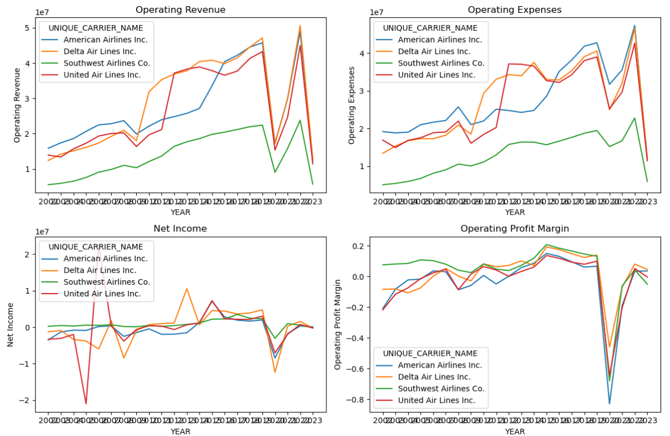

According to Figure 13, Southwest Airlines demonstrates a consistent upward trend in operating revenue, reflecting its strong market position and operational efficiency. Despite facing challenges in the airline industry, Southwest's ability to maintain steady revenue growth indicates its resilience and effective revenue management strategies. Moreover, Southwest's relatively lower operating expenses compared to its counterparts suggest a focus on cost control and operational efficiency, contributing to its profitability.

In contrast, American Airlines and United Airlines show more variability in operating revenues and expenses. This variability may be attributed to factors such as route expansions, competitive pricing strategies, and macroeconomic conditions. American Airlines, for instance, experienced a dip in operating revenue in certain years, possibly due to market fluctuations or operational challenges. Similarly, United Airlines' operating expenses have shown fluctuations, indicating varying cost structures or investment strategies.

Delta Air Lines exhibits stable growth in operating revenue over the years, with some fluctuations likely influenced by external factors such as fuel prices and economic conditions. Despite these fluctuations, Delta has managed to maintain a relatively stable operating expense pattern, indicating effective cost management practices. However, the airline's performance highlights the challenges of the aviation industry, where external factors can significantly impact financial performance.

Overall, Southwest Airlines' consistent growth and efficient cost management set it apart from its competitors. Its ability to navigate market challenges while maintaining profitability underscores its strong operational performance. In contrast, American Airlines, Delta Air Lines, and United Airlines exhibit more variable performance, reflecting the complexities and challenges of the airline industry.

### Operating Expense Composition

#### Fuel Expenses:

* American Airlines: In recent years, American Airlines has spent a significant portion of its operating expenses on fuel, given its large fleet size and extensive route network.
* Delta Air Lines: Delta has also allocated a considerable amount to fuel expenses, although it has implemented various fuel-saving measures and fleet upgrades to mitigate these costs.
* Southwest Airlines: Southwest has traditionally spent less on fuel compared to other major airlines, thanks in part to its efficient operations and hedging strategies to manage fuel price fluctuations.
* United Airlines: United's fuel expenses have been substantial, reflecting its global operations and the impact of fuel prices on long-haul flights.

#### Labor Costs:

* American Airlines: Labor costs are a significant portion of American's expenses, reflecting the large workforce required to operate its extensive flight schedule.
* Delta Air Lines: Delta has also allocated a substantial budget to labor costs, reflecting the wages and benefits of its employees, including pilots, cabin crew, and ground staff.
* Southwest Airlines: Southwest has a reputation for efficient operations and lower labor costs compared to legacy carriers, although labor expenses still form a significant part of its budget.
* United Airlines: United's labor costs are significant, reflecting its large workforce and the competitive labor market for airline employees.

#### Maintenance Expenses:

* American Airlines: Maintenance expenses for American include costs related to the upkeep of its large fleet of aircraft, facilities, and equipment.
* Delta Air Lines: Delta invests heavily in maintenance to ensure the safety and reliability of its fleet, with a focus on proactive maintenance to prevent disruptions.
* Southwest Airlines: Southwest's maintenance costs are relatively low compared to other airlines, thanks to its efficient fleet management and focus on reliability.
* United Airlines: United's maintenance expenses are substantial, reflecting the need to maintain a large and diverse fleet of aircraft for its global operations.

Hence, the operating analysis of the four airlines reveals distinct cost structures and operational strategies. Southwest Airlines stands out with its lean cost management, reflected in lower operating expenses compared to its counterparts. American Airlines and Delta Air Lines demonstrate higher expenses, particularly in labor and maintenance, attributed to their extensive operations. United Airlines shows a balanced approach with moderate expenses across categories. These insights are crucial for understanding each airline's operational efficiency and competitiveness in the industry.

# VI. Insights & Recommendation

* United Airlines experienced significant volatility in net income, partly due to its bankruptcy and restructuring in the early 2000s but was able to improve its financial performance through cost reductions and operational changes.
* Southwest Airlines maintained the most stable financial performance among the top 4 airlines, attributed to its low-cost carrier model, focus on domestic routes, and strategic decisions around fuel hedging, fleet, and customer service.
* Delta Air Lines implemented strategic initiatives like fuel hedging, fleet modernization, and revenue diversification that helped it emerge as the most profitable of the top 4 airlines between 2011-2019.
* American Airlines struggled with high labor costs, operational inefficiencies, and a burdensome cost structure, but saw improvements after its merger with US Airways in 2013.
* Continue to focus on operational efficiency and cost control to improve profitability. The data shows American struggled with high labor costs and operational inefficiencies in the past.
* Maintain strategic initiatives that have contributed to Delta's strong financial performance, such as effective fuel hedging, fleet modernization, revenue management improvements, and diversification of revenue streams.
* United Airlines can explore opportunities to further capitalize on the surge in cargo revenue, potentially by investing in freighter capacity, optimizing cargo operations, and developing partnerships with e-commerce companies.
* Southwest Airlines has historically maintained a strong position in the domestic market with its low-cost carrier model, point-to-point routing, and focus on customer service. Capitalize on Southwest's established brand identity as a customer-centric, low-cost carrier by emphasizing these key differentiators in marketing campaigns and communication strategies.

# VII. Summary

* Fuel costs stand as a significant operating expense for airlines, and periods of high fuel prices can heavily impact profitability. Airlines employ strategic partnerships, route planning, and pricing adjustments to navigate through these challenges.
* Southwest Airlines encountered heightened competition from other low-cost carriers post-2011, posing a challenge to its market dominance. Southwest responded by enhancing customer service, expanding routes, and innovating marketing strategies to maintain its competitive position.
* The surge in fuel prices during 2005-2006 greatly impacted airline profitability, underscoring airlines' vulnerability to fluctuations in fuel costs.
* Delta Airlines experienced a notable revenue surge from 2010 onwards, driven by strategic initiatives such as mergers, fleet optimization, and revenue management strategies. These efforts bolstered Delta's operational efficiency and expanded its revenue streams.
* Strategic alliances and partnerships, like Delta's membership in SkyTeam and United's collaborations with cargo carriers, have played pivotal roles in expanding airlines' global reach and boosting revenue through enhanced network access and resource sharing.